The Response to Poverty

Becca Wheeler

Azusa Pacific University

A Poor Man as King
From Genesis to Revelation, God’s heart for the poor is clear. The clear example is the incarnation of the Messiah. Jesus invaded the Earth not as a King, but as a baby born in a manager. He was a refugee and later did his ministry work as a homeless man. This is the way that God demonstrates his commitment to and identification with the poor (Blue, 2006). Christians are to serve the poor. It is not just a suggestion— but a command from God’s word (Beed, 2010). Despite the overwhelming statistics of poverty, Christians can love the poor because of Christ. Psalm 72 (New International Version) speaks about a just King, a royal son who will deliver the needy who cry out, the afflicted who have no one to help. Jesus is that just King, that royal son. Through his incarnation and teachings, he displays a magnificent example of how the poor should be perceived and loved. Poverty may not be completely eradicated here on Earth, but that does not dismiss the command. The first step is to understand what is poverty and the foundational principles in Scripture that address poverty. From there, believers can come to comprehend that Jesus illustrates, enables and motivates ministry to the poor.

Poverty
World Perspective
Poverty and its effects are seen all over the globe. Strictly looking at an impoverished neighborhood, one can observe the physical differences between it and a wealthy region. In urban areas, it is usually defined on a socio-economic basis. Currently, the poverty line is a determining factor for whether or not a family is struck by hardship. However, poverty is multidimensional in nature— a myriad of factors are at the root of poverty. According to the The Challenge of the Slums: United Nations Human Settlements Programme, a person may experience extreme poorness because basic needs are inadequate, unstable, or not met. They may be living in overcrowded or low quality housing (2003). No access to clean water, adequate sanitation, health care or schools are economic components that play a part. Their safety network may not be supportive. When law and regulations concerning civil and political, as well as economic, social and cultural rights do not protect certain individuals, poverty is likely occur. The lack of life chances that would otherwise benefit one’s growth attributes to this as well. Simply put, poverty is a result of scarce basic needs and opportunities to sustain a person’s well-being.

Yet these causes are just scratching at the surface. A deep root of inequality lies within the realm of poverty. Capitalism can perpetuate this inequality. According to the United Nations Human Settlements Programme, this economic system can be a cycle with periods of prosperity and recession (2003). During the booms, entrepreneurs seek to retain wealth. However, during busts, stock quality drops due to low maintenance on housings and failing infrastructure. In these times, people with low income are driven to poverty and relocate to communities with the lowest cost. In prosperity, because they hold most of the assets, the rich gain more income while in recessions, the poor suffer disproportionately. The rich also are generally more able to protect their wealth when this occurs. It is interesting to note that the gap between rich and poor seems to be the lowest during steady growth periods. The slow increase of demand for labour allows wages to rise and keeps unemployment low. While inequality in capitalism and other economic systems can explain why poverty exists, Christians are to seek deeper roots.

Scriptural Perspective
The reasons leading to poverty are more complex than the insufficiency of income. The United Nations Human Settlements Programme touched on inequality due to capitalism. However, there is a spiritual side to inequality. For an explanation, the Bible is the text to turn to. There are 245 references to the poor, poverty, or the lack of in the Old Testament (Grigg, 2004). According to Scripture, poverty can be caused by three ways: personal sins, calamity, or the sins of the rich. Personal sins such as drunkenness and immorality are like bacteria growing in a petri dish when poverty strikes. Widows and orphans experience calamity through death of a husband or caregivers. Circumstances outside one’s control also include being needy and dependent. Those who are too weak to work have to rely on others. These groups of poor are called blessed in the Kingdom (1 Sam. 2:8 New International Version) throughout Scripture. The last group who experience poverty are at the hands of others. This is caused by affliction of injustice and results in oppression. The oppressed are considered righteous especially, not because of their circumstances, but in contrast to their oppressors’ unrighteousness. In general, poverty is not blessed or ideal. People who experience poverty must rely on God. That spirit of dependence is what set the poor apart.

The concept of poverty and the analysis of its causes and effects alter as the history of God dealing with his people progress (Grigg, 2004). Before David and Solomon, societies were built around extended family and clans. Riches were blessings from God and poverty was brought about by misfortune or through judgment of personal sin. Equality between people was displayed through a simple idea like homes. Beginning in 8th century BC, a center of privileged people develops. Their perspective becomes tainted. Riches were not a gift from God, but an entitlement. From this, districts separated rich and poor. The rich treated the poor as though they belonged to a lower order, as though they themselves were better. As a result, the poor equated poverty with oppression. The prophets denounced the rich who oppressed the poor because it was against the righteous and merciful character of God.

Sin is the root of poverty. Grigg states in the presentation “The Kingdom of God and the Poor” humanity is in need of restoration spiritually, socially, and economically (2013). Restoring an eternal separation from God, injustice, oppression, poverty, and exploitation is an insurmountable task to accomplish alone. How can believers do this? Fortunately, Christians are not charged to restore brokenness individually or without help. Jesus is the provider of resources to undertake these needs. He provides eternal life, community, brotherhood. He provides tangible answers such as food, work, and land. He provides economic developments like equal distribution. Jesus spoke much about the poor in his teachings. He tended to the sick and healed the wounded. To follow Christ is to follow his actions. Caring for the poor is not an option. It is not only for the super Christian or for those who have the gift of mercy. It is not only for those who choose a lowly life. This command is an obligation for everyone who proclaims the name of Jesus Christ. (Beed, 2010).

Okay, so now what?
If God commands believers to care for the poor, how is that command obeyed? Discussions about the solution center around providing the poor with work. However, if poverty is more than a lack of a sufficient income, then the solution must be more than receiving a paycheck.

Importance of Work
Before the creation of humankind, “no shrub of the field had yet appeared and no plant of the field had yet sprung up, for the Lord God had not sent rain on the earth and there was no man to work the ground (Genesis 2:5). Before the fall, Adam and Eve were to rule over creation. They had every seed-bearing plant as provision for food. When they rebelled, part of God’s curse was a cursed ground (Genesis 3:17). Work was and still is a gift from God— we tend to His creation whether it be the land or the people. Because of the fall, work became a painful toil which means that God’s original design for work was good and productive. In the contemporary Christian culture, many believers view work as an important role to free someone out of poverty (Beed, 2010). Despite the good nature of this perspective, providing work is not sufficient enough. There must be a restoration of the ‘productive capability’ of the poor which means providing productive and meaningful work to enable people to be self sufficient (Beed, 2010). God sees value in each and every human being. Work must be valuable too! Providing jobs that help people develop their gifts and talents and help restore the kingdom is what God desires. He is in an intentional God and the gift of work must be too. (Gen. 1:31; Gen. 2:8, 15)

Importance of Participation and Human Dignity
In the Old Testament, wealth was not seen as evil. Wealth in Israel was to be a sign of the interdependence, sharing and mutual support of the tribes for each other (Bellingham, 1984). Numbers 26:54 says: “To a larger group give a larger inheritance, and to a smaller group a smaller one; each is to receive its inheritance according to the number of those listed.” The key words are ‘according to’ which indicates equality. But what happened if inequality suddenly resulted? In Deuteronomy 15, verse 4 says that there should be no poor among you however later in verse 11 the word of God says that there will always be poor people in land. This is not meant to be a contradiction. It served as a reminder of what the state of the world was because of sin and yet a hope for what to strive for. Poverty was not meant and is not to be a permanent condition (Bellingham, 1984).When poverty did occur (because it would), steps had to be taken to redistribute wealth. The Israelites were familiar with oppression, so their generosity was to be extended to sojourners and aliens in their land. God rescued them out of their slavery! They were live out of that redemption. It was also a way to reflect God’s mercy and compassion to others.

A response is outlined in Scripture. Bellingham lays out five Laws from Exodus, Deuteronomy, and Leviticus in relieving poverty (1984). As the table below shows, the laws require participation mainly from God’s people who provide resources for the poor. Tithing, charging no interest, and cancelling debts not only help the poor, but serve as an act of worship, relying on God’s provision. Despite a different cultural context, these principles can be applied. The most obvious is giving 10%. Christians should be letting go of monetary first fruits. Even though the tithe may not go to Levites anymore, it should a regular practice. Gleaning is not as common in this day and age particularly because agriculture is not a conventional career. However, the general idea still holds truth. The concept of this law enables the poor to participate and take ownership.

Five Laws for a Just and Equal Society (According to Bellingham)
  (Image taken from https://rogerupton.wordpress.com/2013/09/11/misused-bible-verses-part-4-malachi-310-the-tithe/) | Tithe 10% | Deut. 26:12 | - First fruits  - Act of Worship  - Trusting in God’s provision  - Levite, alien, fatherless, and widow were usually the poorest in the society
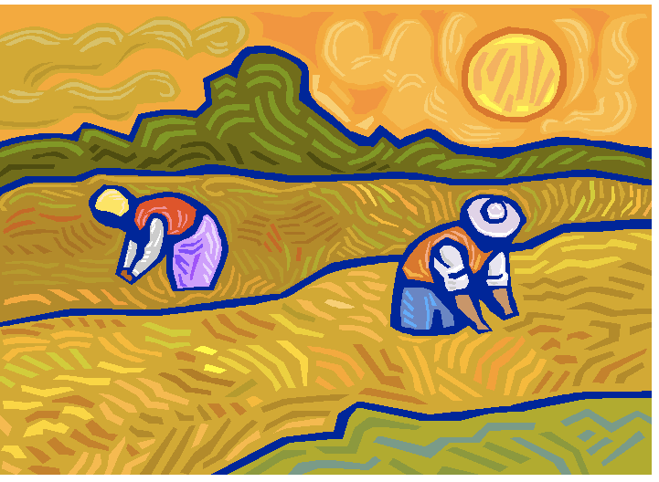  (Image taken from http://greenleaf.uncg.edu/gleaning.html) | Leave crops for the poor to glean | Lev. 19:9-10 | - The poor will eat  - The poor will participate  - The poor gain dignity  - The poor are not given handouts
(Image taken from http://omnicreditimprovement.com/is-0-financing-from-retailers-a-good-deal/) | Charge no interest to the poor | Ex. 22:25  Deut. 23:20  Lev. 25:35-37 | - Unrighteous to do so  - Reflects God’s mercy
  (Image taken from http://www.bankrate.com/financing/insurance/obamacare-deadline-is-stretched/) | Cancel debts every 7 years | Deut. 15:1-11  Lev. 25:1-7 | - Freeing servants from dependency  - Reflects God resting 7th day of creation
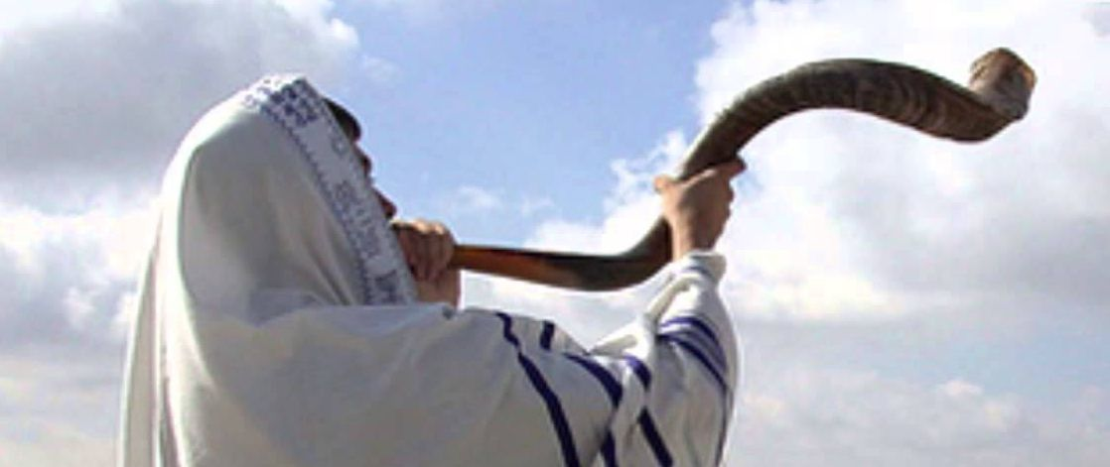  (Image take from http://www.shemitah-blood-moons.net/jubilee.html) | Year of Jubilee | Lev. 25:8-55 | - Equalizing

God knows that calamity is inevitable yet does not want disadvantages to lead to greater divergence of wealth and poverty. The solution was Jubilee! Jubilee is a way of self-help and self-development— a person can have a second chance to make a living and maintain dignity. it is a way of equalizing inequality. inequality will happen, but it should be addressed. God’s people should aim towards redistribution! Besides providing work, another solution seen frequently is giving basic necessities or even money away. The practice of handouts is severely needed for immediate relief. However, to move forward into sustainability and the Kingdom of God, this cannot be the only practice. To contribute to a person’s humanity, dignity, and kingdom purpose, laboring to help them gain necessary skills for self-sustaining employment is best (Blue, 2006). People have a purpose. Ephesians 2:10 states that we are God’s workmanship, created in Christ Jesus to do good works, which God prepared in advance for us to do. When others solve people’s problems for them negates their ability to exercise their creativity. When the poor are participants, rather than recipients, in the problem solving process, they are stronger and wiser for it (Blue, 2006).

Grace Dryness further expands on the perspective in the “Poverty Analysis and Paradigms” presentation that the provision of productive and meaningful work gives the responsibility to the community not just the poor (2013). With this in mind, poverty becomes a public concern, not an individual one. Alleviating poverty is more than increasing the opportunity for the poor to earn high incomes. It involves development that allows people to learn and increase their capacity to do so. In Pedagogy of the Oppressed, Friere writes that “to alienate human being from their own decision-making is to change them into objects.” (Friere, 2000). Poverty affects the whole person therefore the response is to be holistic. Every aspect of a person is a concern to God.

Importance of Christ as Our Example
Further normative principles are provided and intended to improve socio-economic life or the poor and they are meant to be applied. If the principles were to be applied, the current advanced free market system would operate different. There are three main principles from the Mosaic Law give a general guideline of helping the poor (Beed, 2010).

- All members of Israelite society were to provided with permanent and productive full time work
- Work context was predominantly to be within self-owned and self-managed extended-family units with wage labor serving as a temporary expedient and second best condition
- Limited egalitarian bias. Distribute wealth throughout the people.

These principles in the Old Testament help encourage the poor instead of handing out. It prevented viewing the poor’s circumstances as equal to the rest of society. In the New Testament, Jesus’ teachings were directed to both the disciples and the wider body of followers (Beed, 2010). Ultimately, Jesus’ death and resurrection brought fulfillment to the commands of the Mosaic Law. Grace enables believers to carry out these principles well. “Jesus’ first 30 years on Earth was work. The incarnation gives divine approval to and redeems human economic culture.” (Beed, 2010). Because of Christ, the following are three truths can be applied:

- Luke 9:48 “The least among you is the greatest.” Jesus didn’t come in as a ruling King, but as a baby born in a manager. The Gospel of the Kingdom is not just about salvation, saving someone’s soul, but it is about restoring the brokenness between people. The Gospel of the Kingdom is holistic which includes economic restoration. In the Kingdom there is no disparity between the rich and poor. Redistribution of wealth and resources is one of the ways to do this.
- There is no entitlement of any repayment for good works. Service is not to be tainted by pride, but an example of humility (Beed, 2010). The power of this principle lies in the Gospel. God requires payment for sins, but because he paid the ultimate sacrifice through Jesus Christ, serving others overflows from that truth. Works are far greater if they are in the name of Christ and for the Kingdom.
- Greatness is defined as service, not authority. Jesus presents himself as the model leader and instead of exercising control and power (which he had), he served.

The ultimate solution to poverty is discipleship (Grigg, 2004). In Companion to the Poor, Grigg explains that membership in God’s kingdom brings love, releases guilt, heals bitterness and breaks power of drunkenness, immorality, and gambling. It gives motivation for work as well as purpose in work. True disciples help care for the poor who are weak, they aide the widow and orphan, they welcome the stranger and refugee. They fight oppression and justice in the name of Christ and with the power of Christ. The Gospel is judgment to the oppressor. The Gospel is mercy and hope for the oppressed. Charging no interest to the poor and cancelling debts are not viewed as a suggestions, but as principles to follow. Instead of handing out money or resources, Christians understand how life-giving it is to invite people to be part of the solution.

Fruit of Our Labors
It can be disheartening and discouraging to look at the world today and see the fallen nature of humanity so prominently. However, God has tasked Christians to help the poor. Some may believe that the principles outline in the Mosaic Law do not apply because of grace. Since Jesus is the authoritative interpreter of the Law, then believers need to turn focus to what he says in his teachings. God calls Christians to an active pursuit of helping the poor. This can be explicated in various ways to highlight the diverse gifts and talents of God’s people. Action and evangelism should be done hand in hand with compassion and humility woven in with grace and mercy. We will fail, but we must persevere with diligence. We will carry out development theories imperfectly. There will be people that will slip through. In 1 Corinthians, Paul says that he has become all things to all people so that he might save some (1 Cor. 9:22). But it is never about us and it will never be about us. God is concerned with faithfulness, not success. (Blue, 2006).

The stories of the relationships we develop are the best way to portray what God is doing to work towards His kingdom (Blue, 2006). I have met many people in my last three years of living Los Angeles. The previous year I have worked at the same school in the same position in Pico-Union. The effects of poverty are apparent in the community. People do not have the same opportunities as others in different areas. It is easy to choose a life in poverty or sin if there is no other lifestyle presented. I do not see wealth distribution. I see handouts and the community barely respond because they are not participating in their transformation. Meaningful or productive work is rare. God’s intention for people is not to live paycheck to paycheck. His intention is not for anyone to work a ‘dead end’ job to make ends meet. The cycle of poverty is like a vacuum drawing the life and dignity out of the people. From my time at my job, I have been blessed to cultivate rich relationships. These relationships have given me stories of hope. Recently, I met a young man named Erick who is incredibly gifted in art and in tuned with the world around him. He demonstrates diligence and resilience. In the short time I have known him, I begin to understand why God cares so greatly about the poor. He does not view them as impoverished or without, but full of joy and spirit. I also begin to fathom why He commands Christians to serve the poor. Not only is it to extend His grace, but to learn from the people who live a life of faith and surrender.
Bibliography

Beed, Clive and Cara. (2010) Assisting the poor to work: a Biblical interpretation. In Christian
Scholar’s Review XL:1 issn 0017-2251 Fall 2010 P 13-38.

Bellingham, G. R. (2012). A Biblical approach to social transformation. Revised manuscript.
Philadelphia, Eastern Baptist Seminary.

Blue, K. (2006). Practical justice living off-center in a self-centered world. Downers Grove, Ill.:
InterVarsity Press.

Dryness, G. (2013). Poverty analysis and Paradigms: Development as freedom [PowerPoint
slides]. Retrieved from https://sakai.apu.edu/access/content/group/
4479b00c-5ce9-4626-86a7-e7189d69b906/Unit%204/Sept%2024%20TUL500_Poverty
%20Analysis.pdf.

Friere, Paulo (2000). Pedagogy of the oppressed. New York: Continium.

Grigg, V. (2004). Companion to the poor: Christ in the urban slums ([Rev. ed.). Waynesboro,
GA: Authentic Media.

Grigg, V. (2013). The kingdom of God and the poor [Powerpoint slides]. Retrieved from https://
sakai.apu.edu/access/content/group/4479b00c-5ce9-4626-86a7-
e7189d69b906/01%20Patriarchs/ReignOfGodPoverty/The%20Reign%20of%20God
%20and%20the%20Poor.htm.

The challenge of slums global report on human settlements, 2003. (2003). London: Earthscan
Publications.

